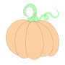
Story Structures can be soooo Sweet!

Read your weekly Story and complete the Graphic Organizer.

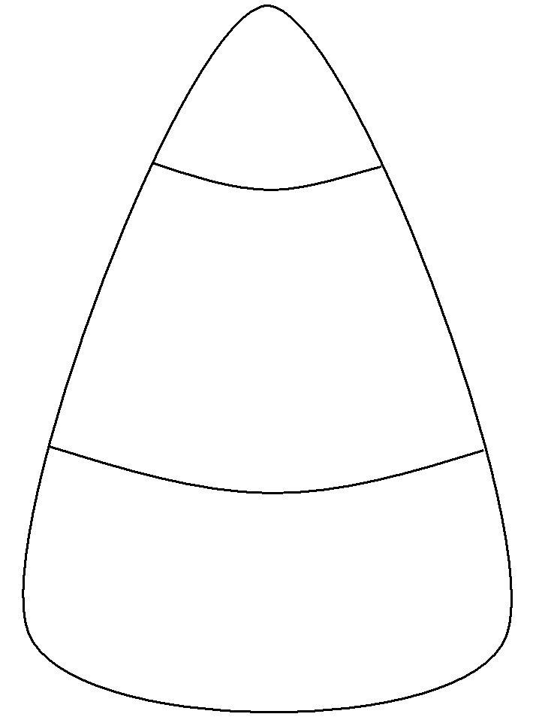
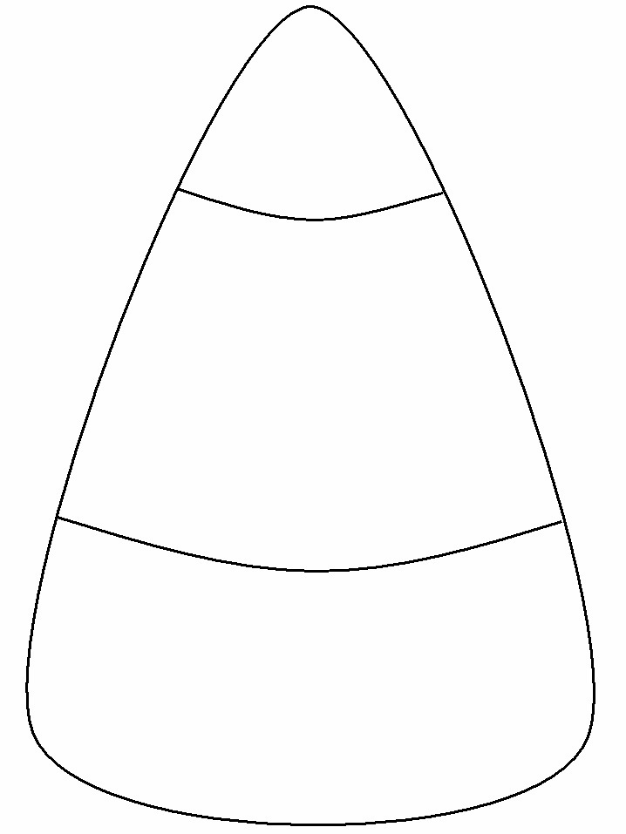
End:
Plot:
Beginning
Middle:
Settings:
Characters:
Story Title:

